Project Design Phase-II
Technology Stack (Architecture & Stack)
Date | 08 October 2026
Team ID | 9100Orbit
Project Name | Implement Client Script & UI Policy (Incident)
Maximum Marks | 4 Marks
Technical Architecture:
The architecture below shows how a Service Desk Agent works with the Incident form in the browser, how the UI Policy and Client Scripts run on the client side, and how the ServiceNow cloud instance stores incident data and the rule definitions. The project runs fully on the ServiceNow platform, so no external API or machine learning model is used.
Example: Enforcing data integrity on Incident records with UI Policy and Client Scripts
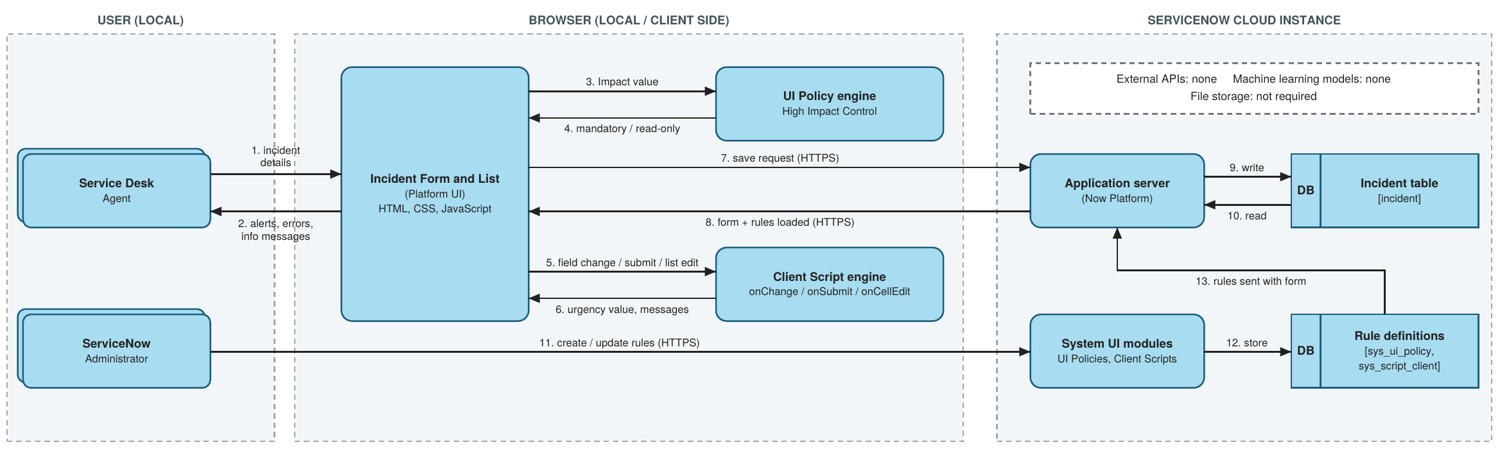
Table-1 : Components & Technologies:
S.No | Component | Description | Technology
1. | User Interface | How the agent interacts with the application: Incident form (create / update) and Incident list view in the browser | ServiceNow Platform UI; HTML, CSS, JavaScript in the browser
2. | Application Logic-1 | UI Policy "High Impact Control": when Impact is 1 - High, Assignment group becomes mandatory and Urgency becomes read-only; effects are reversed when the condition is false | ServiceNow UI Policy and UI Policy Actions (no-code)
3. | Application Logic-2 | onChange client script on Impact: sets Urgency to High and shows an info message | JavaScript, GlideForm API (g_form.setValue, g_form.addInfoMessage)
4. | Application Logic-3 | onSubmit client script: blocks saving a High-impact incident when Assigned To is empty and shows an error on the field | JavaScript, GlideForm API (g_form.getValue, g_form.showErrorBox)
5. | Application Logic-4 | onCellEdit client script on State: blocks State changes made directly in the list and shows an alert | JavaScript, onCellEdit callback, browser alert
6. | Database | Incident records and rule definitions are stored in platform tables (incident, sys_ui_policy, sys_script_client) | ServiceNow platform relational database
7. | Cloud Database | Database service provided with the ServiceNow cloud instance used for this project (developer instance) | ServiceNow cloud-hosted instance database
8. | File Storage | Not required. This solution does not store files | Not applicable (ServiceNow attachments available if needed)
9. | External API | Not used. All logic runs inside the ServiceNow platform and browser | Not applicable
10. | Machine Learning Model | Not used in this project | Not applicable
11. | Infrastructure (Server / Cloud) | Local: user web browser only, no local server needed. Cloud: ServiceNow-managed instance that hosts the application, database and rules | Local: web browser. Cloud: ServiceNow cloud instance
Table-2: Application Characteristics:
S.No | Characteristics | Description | Technology
1. | Open-Source Frameworks | No extra open-source framework is added. Client scripts use standard JavaScript on the ServiceNow platform | JavaScript (ECMAScript), ServiceNow GlideForm API
2. | Security Implementations | Login authentication for every user; only administrative or configuration access can create UI Policies and Client Scripts; scripts run in isolated (strict) mode without direct DOM access; traffic to the instance uses HTTPS. Client-side checks do not replace server-side ACLs and business rules | Role-based access control, ACLs, HTTPS / TLS, isolate script
3. | Scalable Architecture | Multi-tier platform (browser client, application server, database). Rules are defined once on the Incident table and apply to every incident; new rules can be added as extra UI Policy actions or scripts | ServiceNow multi-tier cloud architecture
4. | Availability | The application runs on a ServiceNow-managed cloud instance. UI Policy and Client Scripts are Active and Global, so they are available whenever the instance is available | ServiceNow cloud hosting
5. | Performance | Validations and field changes run in the browser, so no extra server round trip is needed. Scripts are short and lightweight, so the form responds immediately | Client-side execution (UI Policy, Client Scripts)
References:
https://developer.servicenow.com
https://docs.servicenow.com

